Analysis of different search algorithms for Air Cargo Problems

Yazhuo Li

This report will show the analysis of different search algorithms – uninformed search and informed search with different heuristics. Different performance aspects, namely complexity in terms of memory space, search time and optimality (how optimized the solution is) are studied against these algorithms.

Air cargo problems are used in the study. Results will cover performance over different domain sizes – how many actions are taken. There are overall eleven search algorithms used for comparison: Three uninformed ones – **Bread First Search (BDS), Depth First Search (DFS), Uniform Search**. Two Uniformed search – **Greedy Best First Search (GBFS)** and **A-Star** with four heuristics: **Unmet goals, level sum, max level** and **set level** of planning graphs.

Search complexity

**Table 1** shows the result of search complexity, more specifically, number of nodes expanded. More expanded nodes mean more complexity in algorithms. It will take up too much memory space especially when domain size is large.

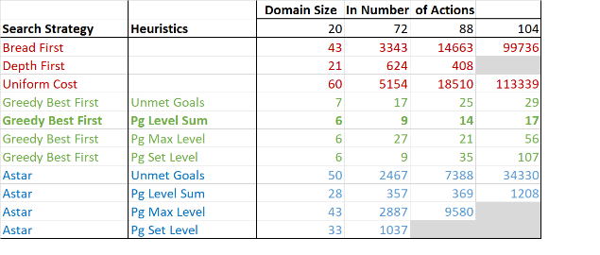

**Table 1**. Complexity (Number of nodes expanded) Result based on different search algorithms

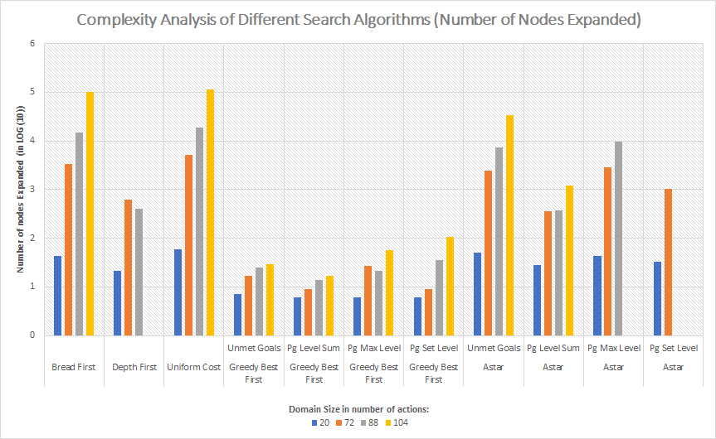

**Figure 1**. Complexity analysis of different search algorithms (Number of nodes expanded)

**Figure 1** illustrates the number of nodes expanded based on different domain sizes. As domain size increases, **Bread First Search** and **Uniformed Search** grows exponentially due the nature of these algorithms expanding the search tree. Same goes with **A-Star** Search. When domain size reaches 104, as seen **Table 1**, **Uniform Cost Search algorithm** has expanded to 113339 nodes. This is considered the worst performer as the algorithm takes up too much memory space. On the other hand, **GBFS with Level Sum** is considered the best performer. **GBFS with Unmet goals** also shows few expanded nodes as the second-best performer.

Search time

Search time is another key factor to be considered when conducting search. Some problems may be time sensitive when long search time is not desired. **Table 2** shows the result of search time of different search algorithms.

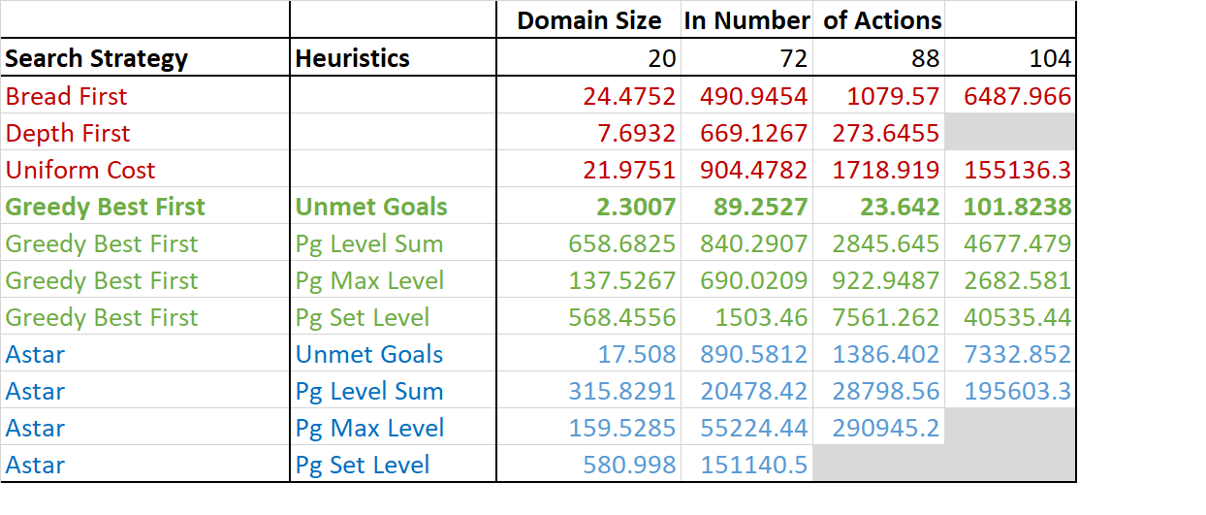

**Table 2**. Search Time Result Based on Different Search Algorithms

When domain size reaches 104, search time for Depth First Search, A-Star with Max level and A-Star with Set level are too long so that these two are dropped from the study.

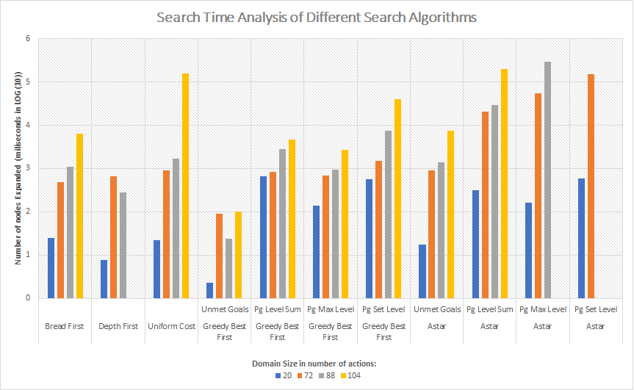

**Figure 2**. Search Time Analysis of different search algorithms

**Figure 2** illustrates the result of search time based on different search algorithms. **GBFS with Unmet Goal** heuristic offers the shortest search time. **Depth First Search**, **Uniform Cost Search and** **A-Star search with Level Sum, Max level and Set Level** all have the long search time

Optimality

Whether the solutions found by search algorithms are optimal is also studied. **Table 3** shows the result of plan lengths found by different algorithms. This indicates how optimized a solution is, shorter planning lengths means more optimized solutions.

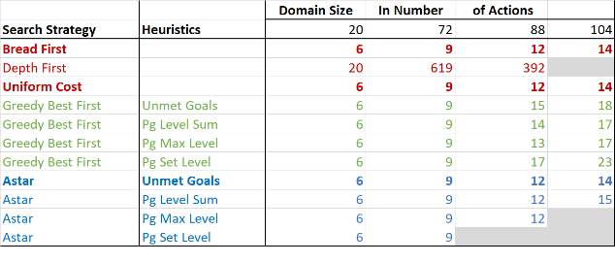

**Table 3**. Optimality Result Based on Different Search Algorithms

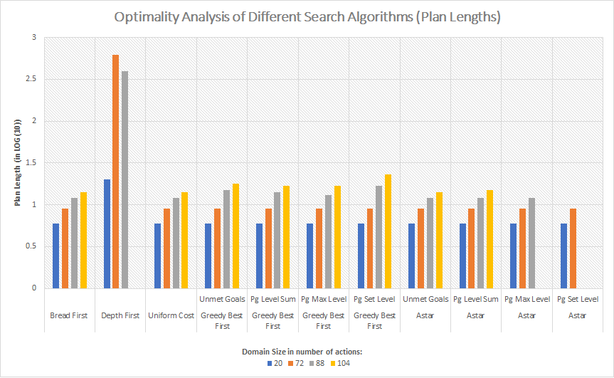

**Figure 3**. Optimality Analysis of Different Search Algorithms (Plan lengths)

There are multiply algorithms reached optimized solutions in this study. **Bread First Search, Uniformed Search** and **A-Star with Unmet Goals** all found optimized solutions. **Depth First Search** on the other hand, performs the worst in solution optimality.

QUESTIONS

* *Which algorithm or algorithms would be most appropriate for planning in a very restricted domain (i.e., one that has only a few actions) and needs to operate in real time?*

In very restricted domain, memory space is not too big a concern. In this case, **Bread First Search** and **Uniform Cost Search** are great in operating in real time while guarantee optimized solutions. **GBFS with Unmet Goal** is also a good choice when close-to-optimal solutions is acceptable.

* *Which algorithm or algorithms would be most appropriate for planning in very large domains (e.g., planning delivery routes for all UPS drivers in the U.S. on a given day)?*

When planning in very large domains, **GBFS with Unmet Goals** is the ideal candidate with short search time and little memory space needed when dealing with large domain problems. However, it is important to keep in mind though, it does not guarantee optimized solutions.

* *Which algorithm or algorithms would be most appropriate for planning problems where it is important to find only optimal plans?*

**Bread First Search, Uniform Search** and **A-Star with Unmet goals** will always find optimal plans. **Depth First Search** is the least recommended in this case.